# **Methodological Investigation: The Transmission, Management, and Prevention of Rabies Outbreaks in Kazakhstan**

# Rabies is a viral and zoonotic disease, meaning that it is an infectious disease that is transmitted between animal and human species. Rabies is present on all continents; however, it primarily targets poor communities living in remote locations. Rabies is a deadly disease if left untreated. Dogs are identified as the main source of transmission cases to humans. The most common method of transmission is saliva, which occurs during bite and scratch incidents. The incubation period of rabies is around 3 months, yet the time may vary depending on the location of virus entry. The rabies virus causes inflammation of the central nervous system, specifically fatally targeting the brain and the spinal cord. Rabies is one of Kazakhstan’s current epidemiological issues. The primary prevention method is animal vaccinations; however, the currently used approach has not been proven very effective (2). Post-exposure prophylaxis treatment, which is prescribed to people who have gotten bitten by an animal, is the most common treatment method for rabies. Although effective, post-exposure prophylaxis translates into a large cost for Kazakhstan’s economy. It is sometimes deemed highly wasteful because not all animal bites automatically equate to transmission of rabies (2). Unnecessary administrations of the shots can lead to a shortage in a critical scenario. Similarly, people from poor villages, who are naturally at a higher risk of rabies transmission, do not live in close proximity to medical centers, and therefore are unable to receive treatment. Post-exposure treatment is the biggest contributor to the annual total loss from rabies, which is evaluated at $20.9 million annually and severely damages Kazakhstan's economy (2).

The central research question of this investigation is how do rabies outbreaks occur in Kazakhstan and what could be done to prevent them. Abdrakhmanov et al. applied a maximum entropy model to identify areas with the highest risk of rabies outbreaks. This method can help to better allocate veterinary service resources for surveillance and vaccination to prevent the development of epizootic rabies and its diffusion into rabies-free zones. Researchers used secondary data from the national database of rabies outbreaks in Kazakhstan from 2003-2014 provided by the veterinary services of administrative territories as shown in the map on the right and in table 1. The database contains information on the cases of rabies outbreaks in farm livestock, domestic animals and wild animals. The data had a spatio-temporal dimension. While the veterinary database is reliable, there is a chance that not all rabies outbreaks were recorded because of the lack of technology in some rural parts of Kazakhstan. Another set of data that the researched used was taken from WorldClim and included remotely sensed data on temperature, precipitation on the Earth’s surface, altitude above the mean sea level. The third set of data which included the green vegetation fraction and land cover data was gathered from the United States Geological Survey from 2015. The data had a spatial dimension. All the data regarding variables was sized to only include the area inside Kazakhstan's borders and was resampled to a common spatial resolution of 1x1 km. The data can be considered valid because it came from outside-of-Kazakhstan sources that are well-known and trustworthy, such as Worldclim and the United States Geological Survey (1). 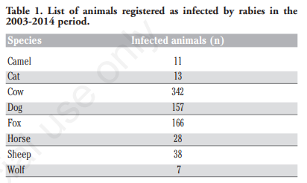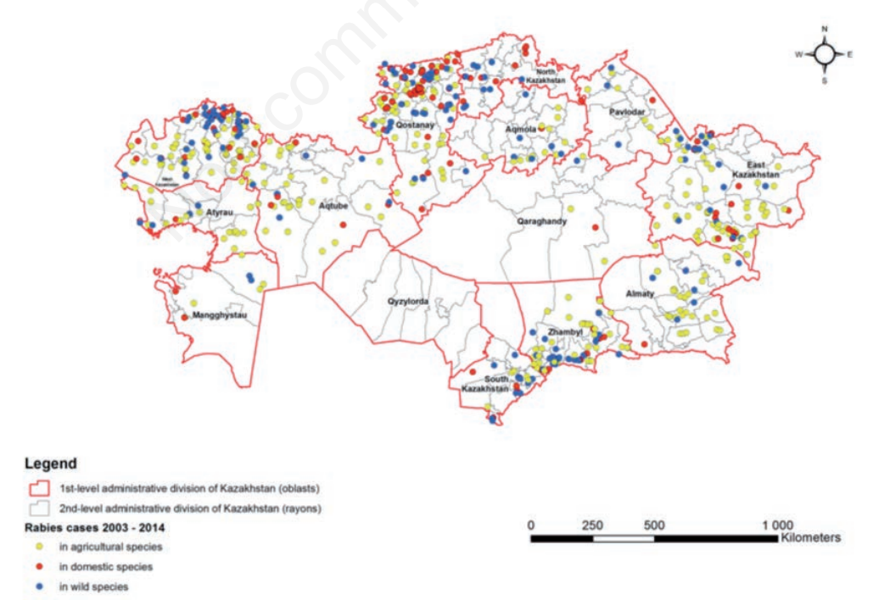

In order to identify the predominant trend of rabies outbreaks in animals in areas with specific combination of natural and climatic factors, the authors used a maximum entropy 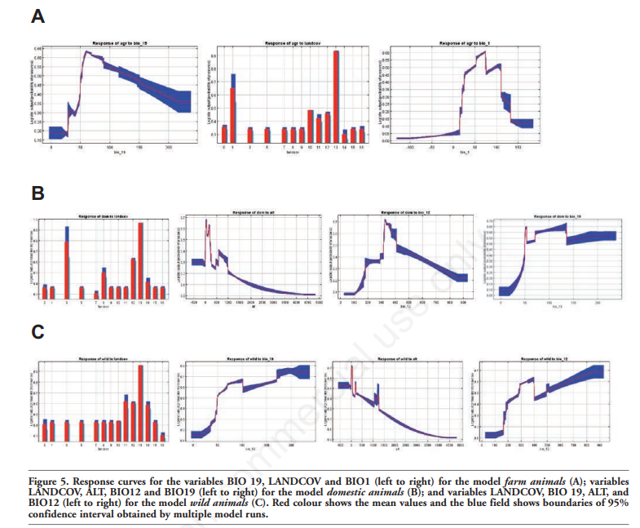method. The goal was to establish a relationship between the rabies outbreaks locations and potential environmental factors. Modeling, which can be seen in figure 5, was done separately and performed in 10 iterations for each category of the animals: domestic, wild, and farm livestock. To compensate for the possible bias of data caused by uneven diagnostics, the road density grid was used. This adjustment followed the assumption that cases are more likely to be reported in close proximity to roads and settlements. The authors created receiver operating characteristic curves which reflected the ability of a model to explain the data available. Using a 95% confidence interval, any area bigger than 0.7 indicated a strong ability of a model to represent data. Areas under the curve for all three animal groups were higher than 0.7 making the study’s findings reliable. The created map of the risk levels of rabies outbreaks across all three animal specie categories, as shown in figure 6, is useful to Kazakhstan’s government and veterinary services. The zoned map allows for prediction of future outbreaks because of its potential use towards better allocated vaccines and surveillance resources (1).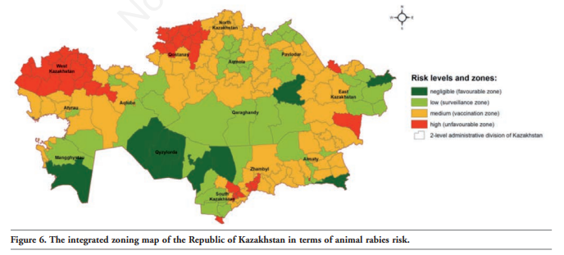

# The authors find that for the farm livestock animals the variables that correlated the most with outbreaks were temperature, precipitation, and type of land cover they live on. The variables that correlated the most with outbreaks in the domestic animals category was the type of land cover they live on, altitude level, and the green vegetation fraction. Similarly, for the wild animals category: variables of temperature, precipitation, altitude level, green vegetation fraction, and the type of land cover the animals live on were the ones most correlated with rabies outbreaks. The authors found that overall the most significant contributors amongst all three animal categories were the prevailing type of land cover and the amount of precipitation in the coldest quarter, while the average annual rainfall and altitude were also important. The authors’ map showing the territorial distribution of risk supports an assumption regarding the existence of natural disease’s foci and of strong interference between epizootic processes in these sub-populations. The area with the highest risk was found to be concentrated along the borders of Kazakhstan with neighboring countries. The authors suggested a possibility of rabies importation from abroad. (1)

# Another group of researchers, Sultanov eat. Al, mapped the livestock rabies cases as well as determined the economic impact and human burden of rabies. In terms of relation to my research question of how do rabies outbreaks occur in Kazakhstan and what could be done to prevent them, the study examines the substantial economic cost and health impact of rabies that could be lessened with a modified vaccination approach (2).

# The animal data used for the study was taken from the Republican Veterinary Laboratory where rabies were identified through animal brain tissue analysis. Samples from the hippocampus and the cerebellar cortex were examined until direct fluorescent antibody test; the results of which can be seen in Figure 1. Statistical data was also gathered from the Ministry of Agriculture, Veterinary Control, and Monitoring Committee reports. Each outbreak, which was defined as the presence of two or more rabies cases at the same time with the same GIS coordinates, as well as animal vaccination statistics, and expenditures associated with the capture and destruction of stray dogs were gathered. In terms of human rabies data, the number of individuals who suffered from animal bites as well as administration numbers of the post-exposure prophylaxis were gathered from the government statistics. The gathered data was secondary data and had a spatio-temporal dimension. The data can be considered reliable because it came from official government data and veterinary laboratories. However, the scarcity of reliable rabies reports and examination centers around the country of Kazakhstan must be considered when evaluating the data (2).

# In order to create a chart of the relative contributions of different cost items to the total economic loss caused by rabies, the researchers used uncertainty limits to fit each cost item to a betaPERT distribution in R. In order to sum up the total costs, which was repeated 10,000 times, random draws were taken and divided by a random draw that estimated the cost of one post-exposure prophylaxis treatment. Secondly, through using data provided by the Veterinary Control Committee, the scientists have compiled probabilities of body parts being prone to rabies transmission through bites. Third, the researchers created a geographical distribution of rabies cases, which can be seen in figure 2, by mapping incident cases onto relevant coordinates using Global Position System receivers. Kernel density was used to analyze the distribution and density of outbreaks. Economic loss and disease calculations were compiled in R and incorporated uncertainty using Monte-Carlo simulations. 10,000 repetitions were conducted where a mean and 95% percentiles were identified. Fourth, the researchers created a model in order to determine whether or not foxes are the primary rabies reservoir amongst animals. To do so, they analyzed the mean number of cases per oblast for every animal species group and created a negative binomial regression model that used confirmed foxes and dogs cases as independent variables. All the methods used by researched are significant to the greater understanding of rabies as a disease and its presence specifically in Kazakhstan (2).

# The researchers found that amongst all rabies cases, cattle had the highest number of cases (712), then dogs (242), foxes (226), sheep and goats (124). This finding is significant because it shows that cattle are the most at risk for rabies transmission and therefore are candidates for vaccination from the government. Secondly, the researchers found out that south Zhabyl Oblast and north Kostanay oblast hosted large clusters of rabies outbreaks. Such finding can be used to allocate more resources to those regions and prevent future outbreaks. Third, the researchers discovered an increasing trend in animal vaccinations, which can be seen in figure 5; yet, they found that one of the two vaccines, Raksharab, was ineffective in rabies antibody production. This finding is important because the associated costs could be better used towards a more effective vaccine or post-prophylaxis treatment which was estimated to cost $147 per treatment. Additionally, the scientists were able to formulate several findings that expand the understanding of rabies. One is that bites to the head have a probability of 0.55 of transmitting rabies, bites to the upper extremity a probability of 0.22, to the trunk 0.09, and to the lower extremity 0.12. The lower extremities, however, were the body part most susceptible to a bite injury that accounted for 49.7% of all incidents. Arms suffered 28.5% of all bite injuries, the head area was evaluated to incur 5.2% of all incidents, and shoulders and trunk presented 9.7% of all injuries. Similarly, children at the age of 6-14 were found to be at increased risk of receiving a bite injury. Using a chi squared statistical test with a p-value of 0.0001, the group was predicted to only receive 50,501 bites, whereas in reality 95,185 incidents amongst children were reported. The group only represents 13% of the total population of Kazakhstan; yet suffered 24.5% of all animal bite injuries. Such information is useful to the government for educational purposes but also allows for better resource allocation. Though the percentage of rabies-infected animals amongst those who were involved in biting incidents is only 0.78%, the economic price of one rabies case is $76,908. Therefore, the researchers claim the post-prophylaxis treatment to be cost-effective, though they find that the total cost of using the treatment is $9.1 million annually. Production losses from premature deaths were estimated at $5.4 million. $3.4 million was found to be the mean cost of catching and terminating wild and stray animals who were believed to have rabies. The total cost of animal vaccinations was estimated to be $1.7 million annually, and $719,000 was estimated to be the cost of distributing bait vaccines. The total cost of livestock loss was estimated to be $23,581, which the researchers deemed as relatively low. The total cost of rabies for Kazakhstan was found to be $20.9 million annually. The above-explained breakdown of the costs can be viewed in figure 6. The researchers suggest a modification to the current vaccination program in order to reduce the overall economic burden. Specifically, they suggest that only dogs and foxes be vaccinated, which would indirectly protect the livestock. The researchers also executed a negative binomial GLM to determine the relationship between rabies cases in various species. The analysis showed no significant relationship between the rabies cases in dogs and agricultural animals. Similarly, there was no relationship found between human rabies cases and fox rabies cases. However, the regression analysis demonstrated a correlation between the number of rabies cases in agricultural animals and cases of rabies amongst foxes. The authors use the finding to proclaim foxes to be a dangerous transmitter of rabies in Kazakhstan and add sylvatic rabies to the description of rabies in the Kazakhstan area (2).

# 

# Overall the two studies used some similar data science methods in order to create a rabies-related map of Kazakhstan. The first group of researchers used a zoning method to assess risk of various areas, whereas the second group created a kernel density estimation of future outbreaks.

# The available literature lacks a more careful examination of the available diagnostic tests for rabies and their possible integration into rabies treatment protocols in Kazakhstan. This element may be essential to answering the central question of my research. The use of diagnostic testing could eliminate the overuse of the post-exposure prophylaxis treatment. It would also allow for a method of rabies detection in animals for those cases where the animal involved was not a stray or wild animal. Further research could also include introduction of various other geographical and environmental variables into the zoning model.

**Works Cited**

1. *Sarsenbay K. Abdrakhmanov, Akhmetzhan A. Sultanov, Kanatzhan K. Beisembayev, Fedor I. Korennoy, Dosym B. Kushubaev, Ablaikhan S. Kadyrov. “Zoning the Territory of the Republic of Kazakhstan as to the Risk of Rabies among Various Categories of Animals”. In: Geospatial Health 11.429* (2016).
2. Akmetzhan A. Sultanov, Sarsenbay K. Abdrakhmanov, Aida M. Abdybekova, Bolat S. Karatayev, Paul R. Torgerson. “Rabies in Kazakhstan”. In: *PLOS Neglected Tropical Diseases* (2016).